Analysing UDP datagrams using Wireshark: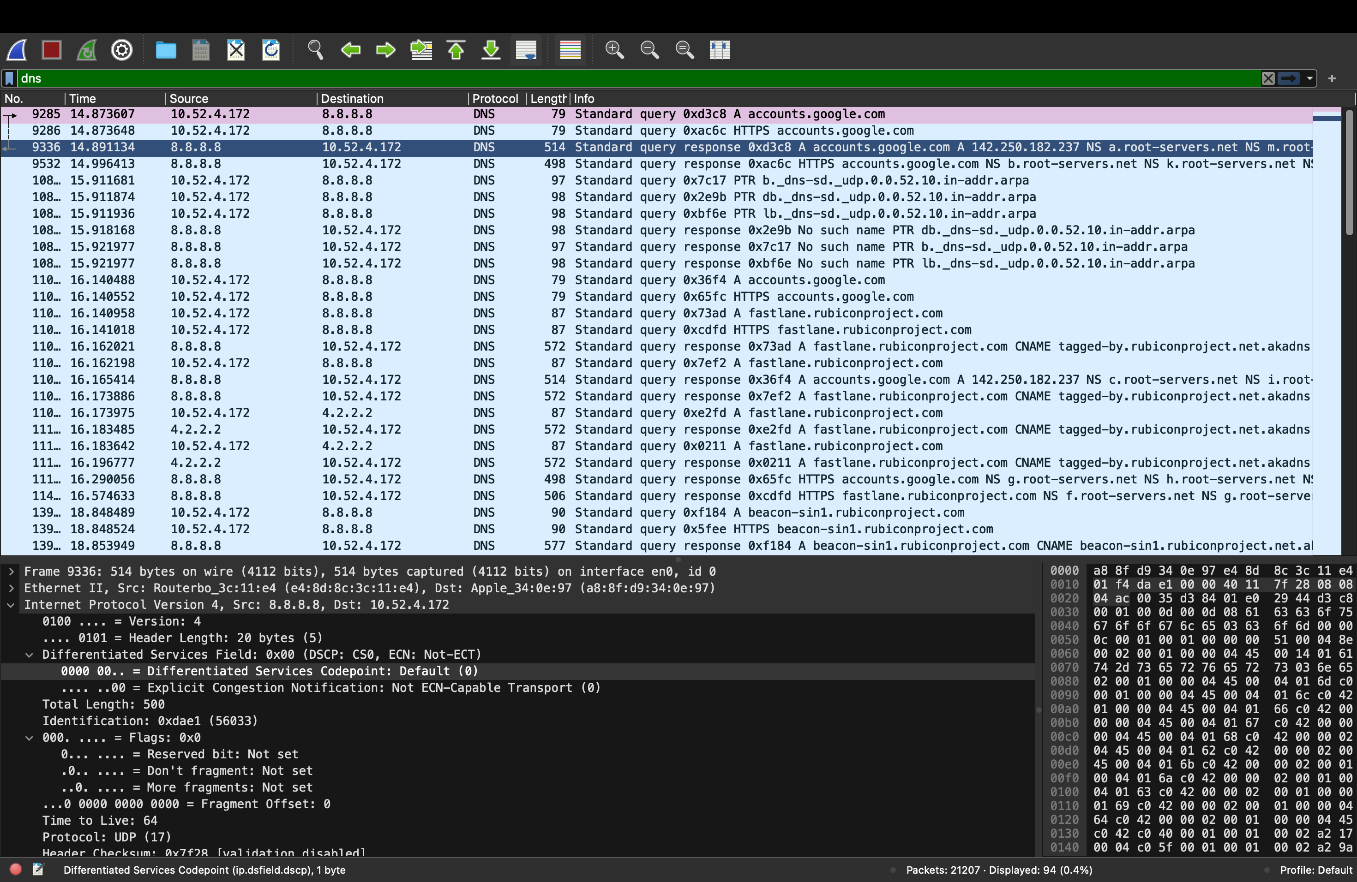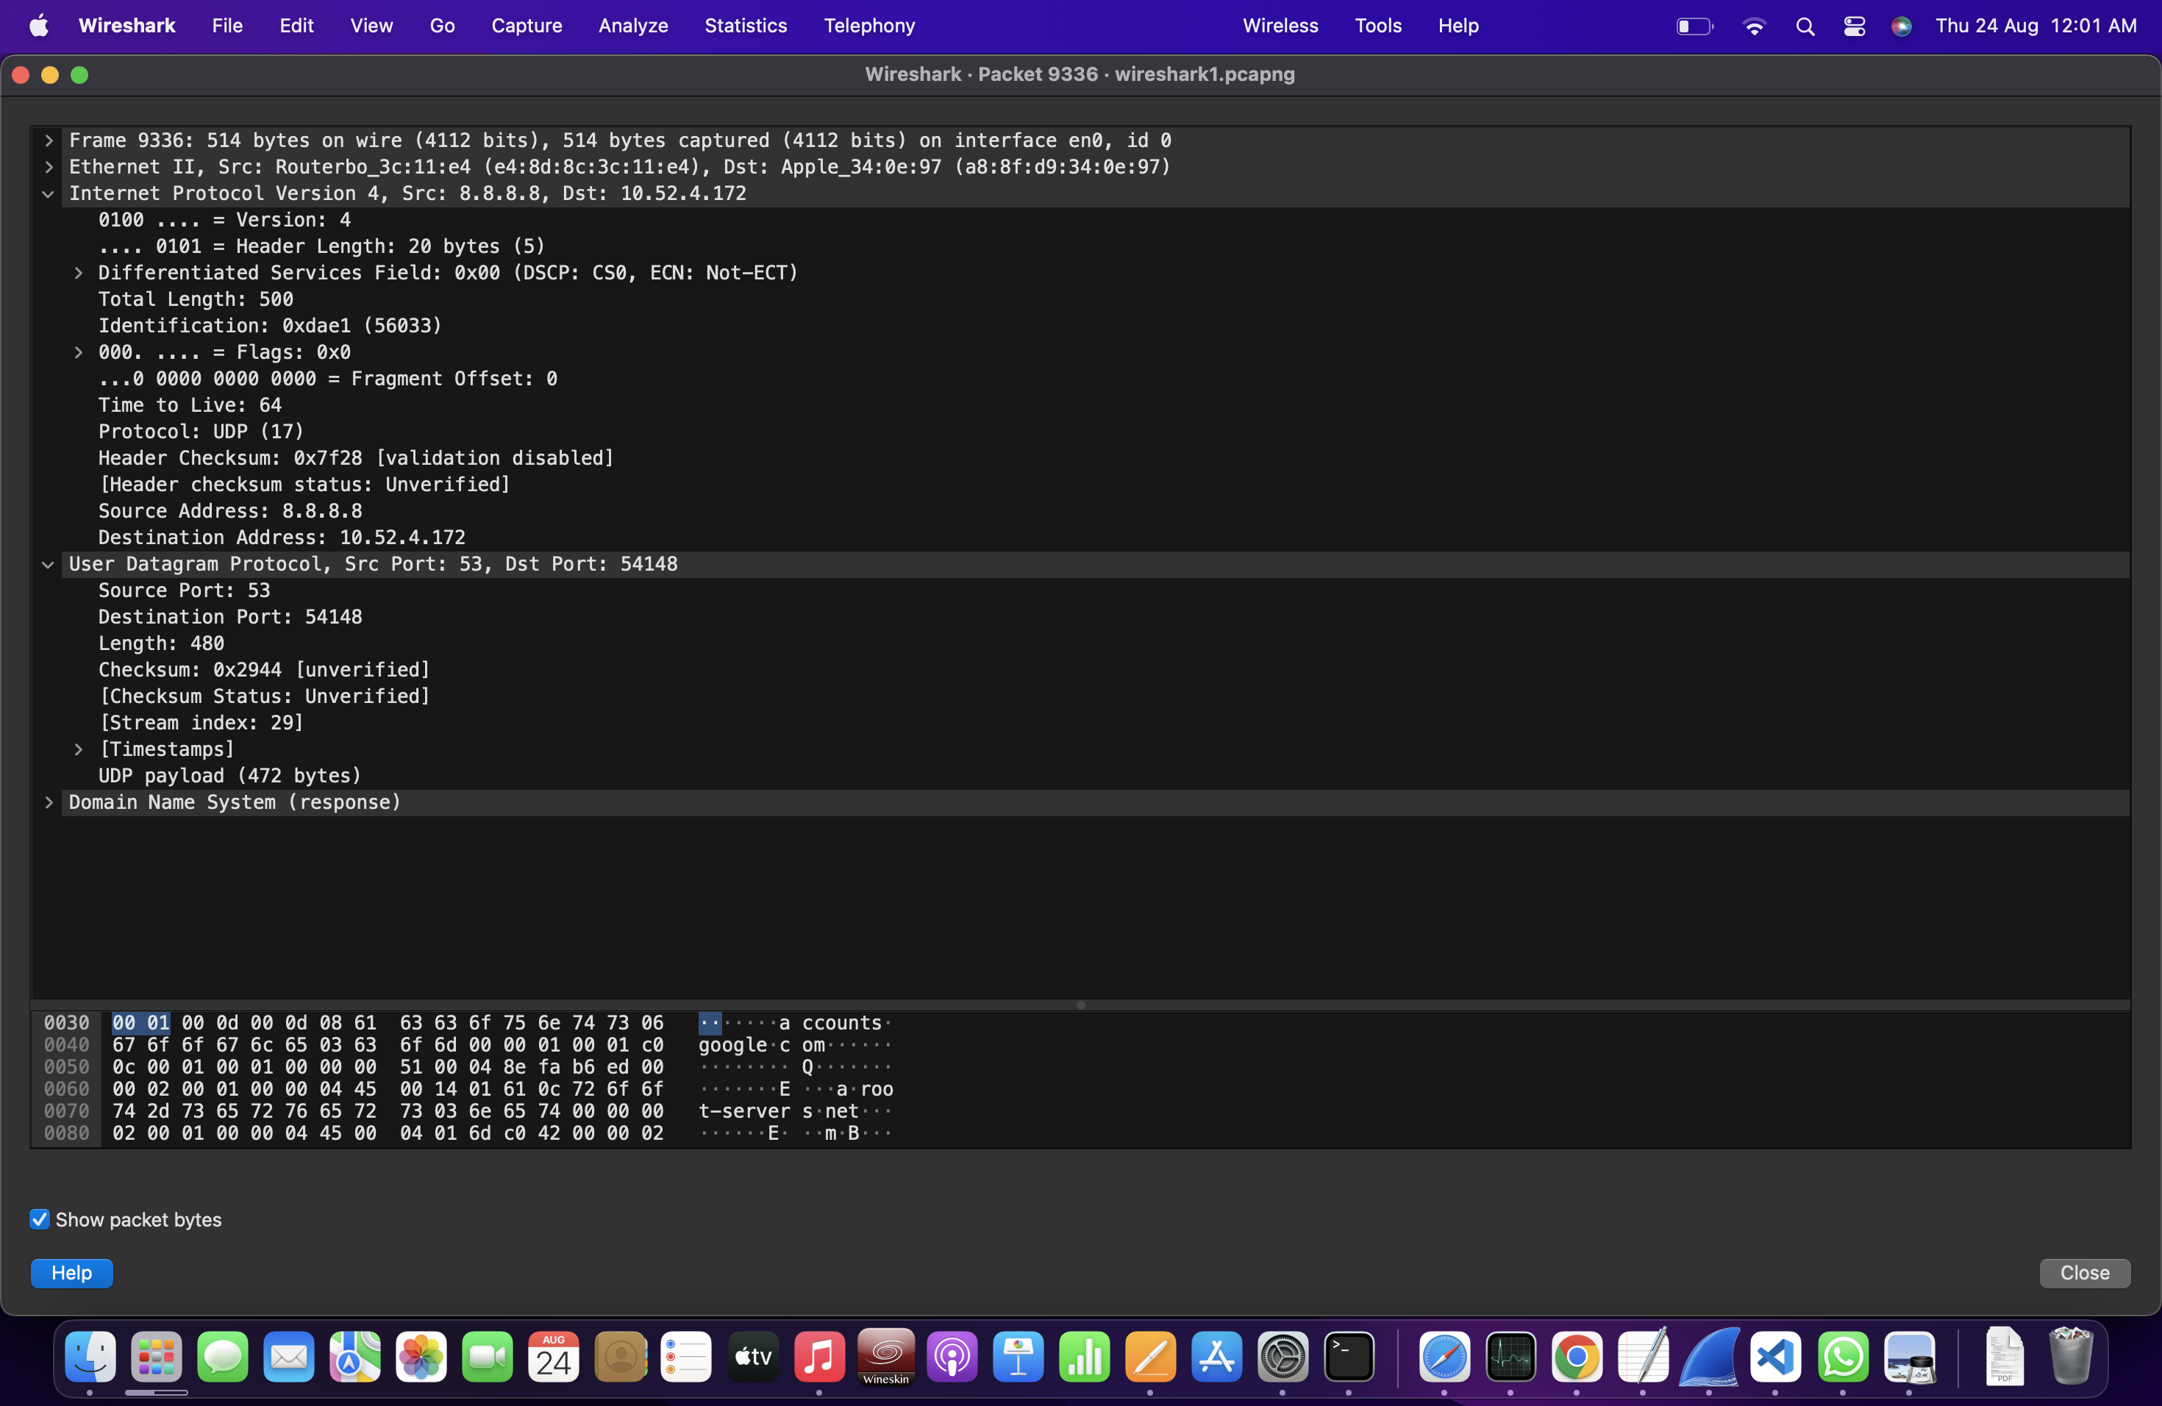

Analysing TCP packets using Wireshark:

1. Connecti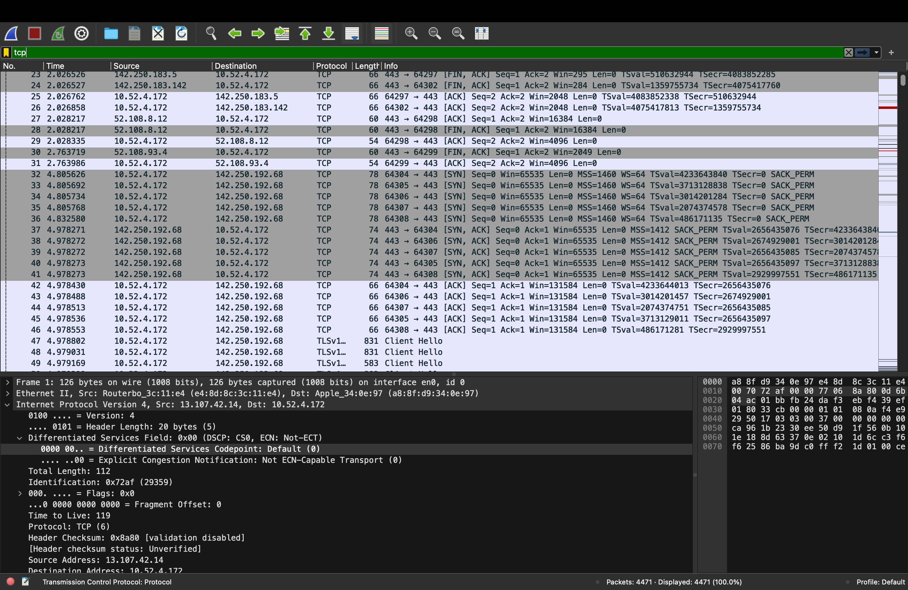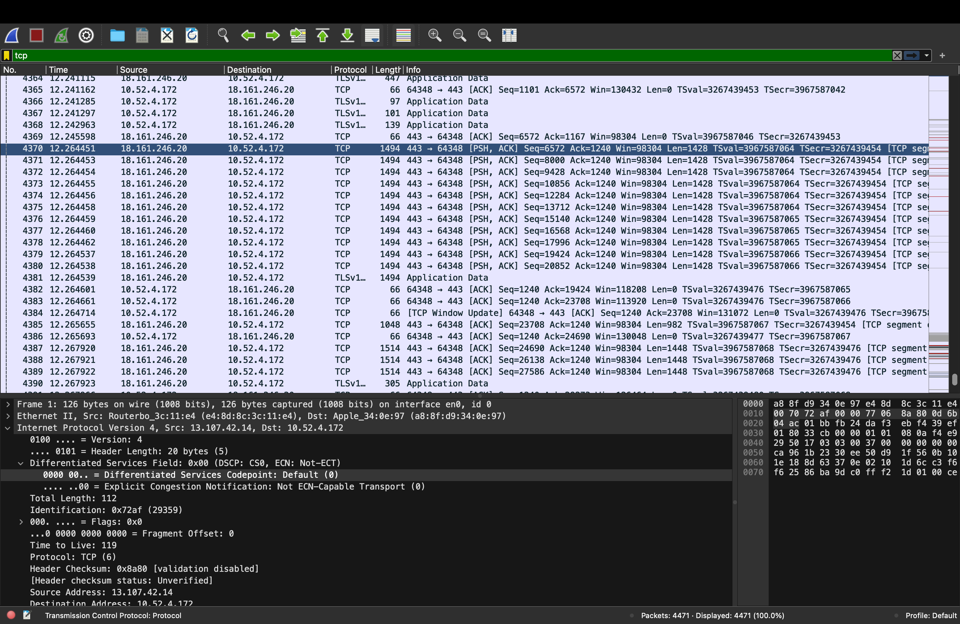on-Establishment Phase

2. Data-Transfer Phase

3. Connection-Te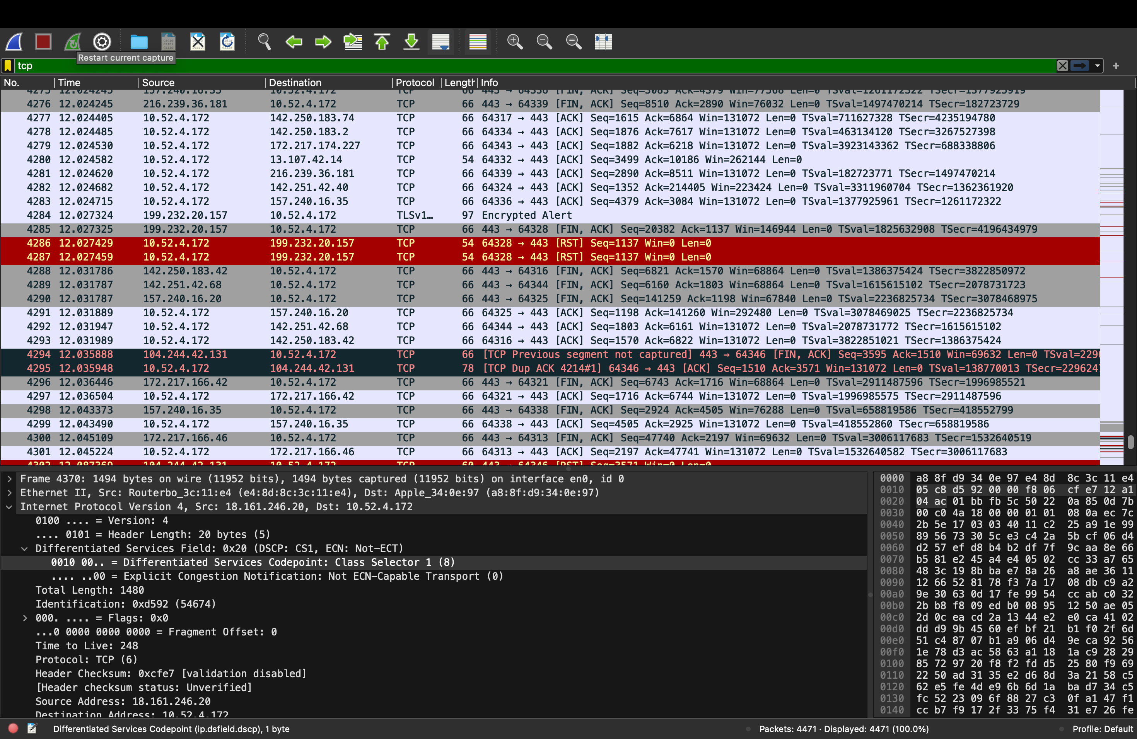rmination Phase

